**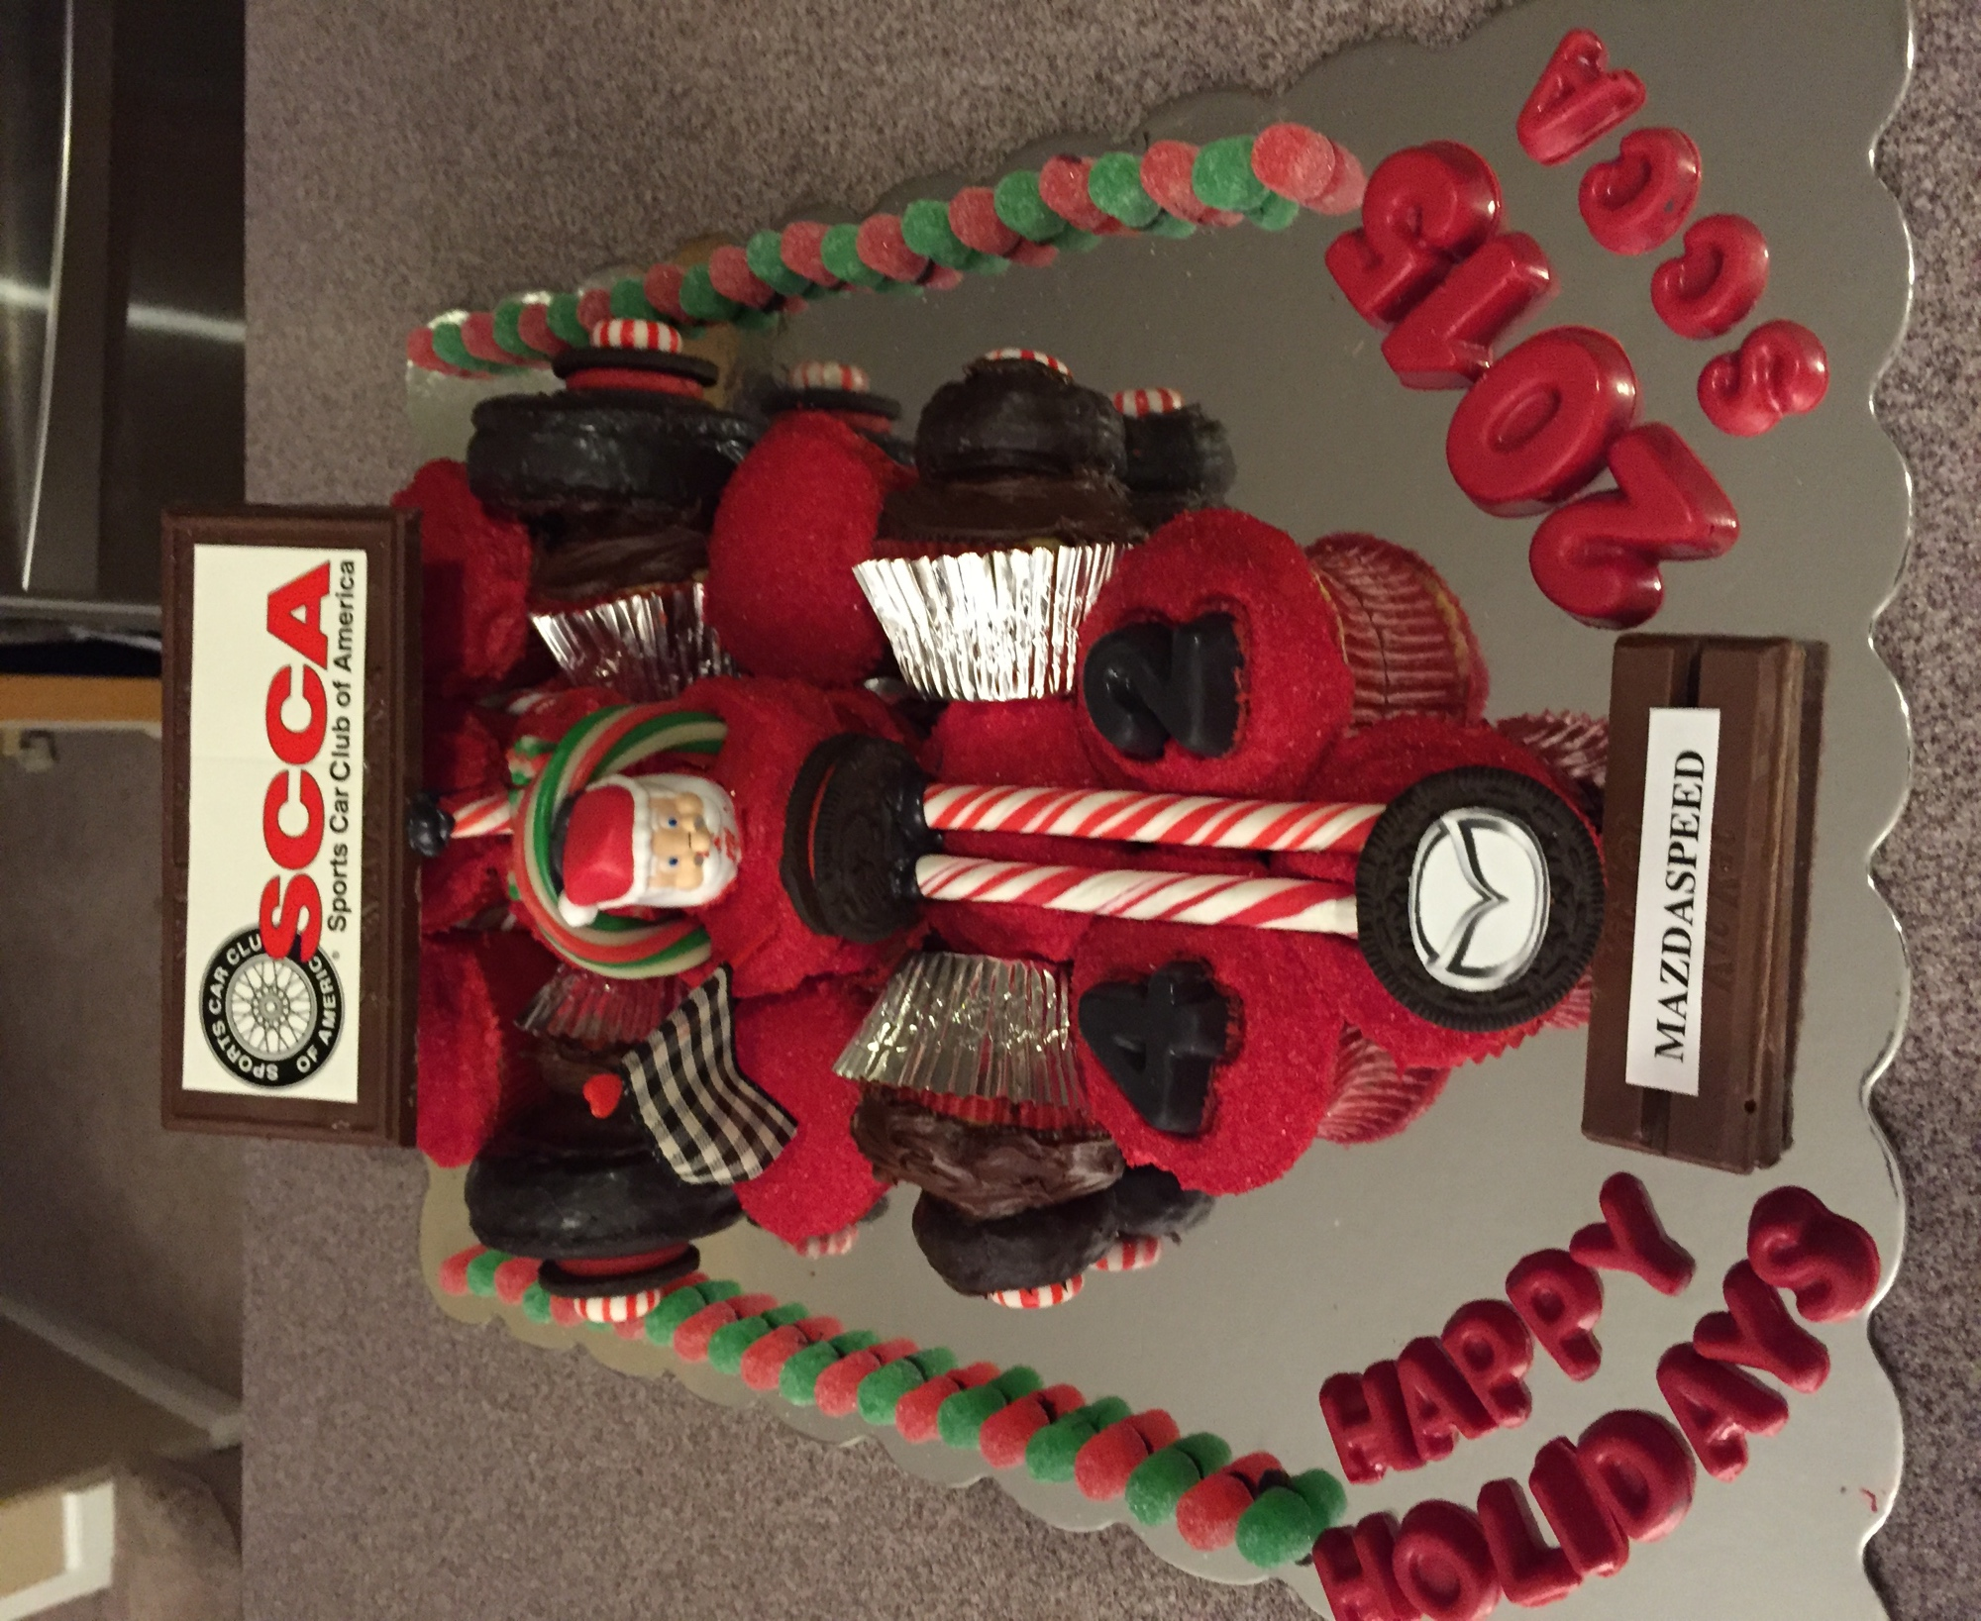**

Table of Contents

[From the Editors 3](#_Toc440613160)

[Letters to the Editors 4](#_Toc440613161)

[2016 SCCA Runoffs Qualification Criteria 5](#_Toc440613162)

[2016 Rocky Mountain Division Schedule 6](#_Toc440613163)

[2016 Tech Stations in RMDiv 7](#_Toc440613164)

[2016 RMDiv Rules 8](#_Toc440613165)

[The Good Old Days 11](#_Toc440613166)

[Spec Boxter CRE 13](#_Toc440613167)

[Fast Lap for NOLA Motorsports Park 14](#_Toc440613168)

[Quad Regionals – A New Driver’s Four-Leaf Clover 15](#_Toc440613169)

[The Quest 16](#_Toc440613170)

[SnakeBytes 18](#_Toc440613171)

[The 2016 Air-Cooled Sprints 19](#_Toc440613172)

[Tall Tales: Toyota Tundra TRD Pro 20](#_Toc440613173)

[Classifieds 23](#_Toc440613174)

[Advertiser Index 26](#_Toc440613175)

[In your Mirrors 27](#_Toc440613176)

****

On the Cover:

SCCA Convention Cake by **Sandra Scofield** of Scofie’ s Cakes.

Sandra’s Facebook page is:

https://www.facebook.com/search/top/?q=scofiecakes

**Publisher:**

Colorado Region SCCA

**Co-Editors:**

**David Muramoto Ed Shuler**

[Nissan7gt3@comcast.net](mailto:Nissan7gt3@comcast.net) <mailto:eshuler@mac.com>

(303) 752-9777 (303) 910-0147

**Copy Editors:**

**Ansley Shuler** and **Kathy Muramoto**

*Redline Magazine* is a monthly e-publication presented by the Colorado Region SCCA and is published 11 times annually. No part of this magazine may be reproduced in any form without the express written permission of the editors. This publication is distributed with the understanding that the information presented herein is from various sources for which there can be no warranty or responsibility by the publisher as to accuracy, safety or completeness. The editorial staff will consider any stories, photos or artwork for future publication, and any unsolicited material may be sent to the editors at the addresses listed above. Unsolicited hardcopy materials will not be returned.



From the Editors

Welcome to the February issue of Redline. What do you think of the new format? We continue to experiment with content development, so you may see some subtle changes in font selection and header and footer definitions. We will eventually settle on standard fonts and layouts, but the experimentation continues at this point. We are always looking for content, so get your reporter hat on and send us something. We are seeking stories that tell YOUR tale—whether it’s driving, wrenching or working—in this great club of ours. Don’t forget to “*LIKE*” us on the [Colorado Region SCCA Facebook Page](https://www.facebook.com/Colorado-Region-SCCA-142377545821488/).

All your favorites are here this month, **SnakeBytes**, **Good Old Days, The Quest** and a review of the 2015 Toyota Tundra.

We have a plethora of information regarding the upcoming season, including **RMDiv class rules**, **Tech Stations**, and articles about the new **Spec Boxster** and new **2016 Air-Cooled Sprints series.**

Once again, let us know what you think of the NEW and IMPROVED Redline magazine. Please send all correspondence to [redline@coloradoscca.org](mailto:redline@coloradoscca.org)

**Shameless plug no 1**. For up to the minute details concerning region activities, check the club website <http://www.coloradoscca.org>.

**Shameless plug no 2.** You can converse with fellow members on matters relating to almost anything club racing related on the message boards. <http://www.coloradoscca.org/msg>

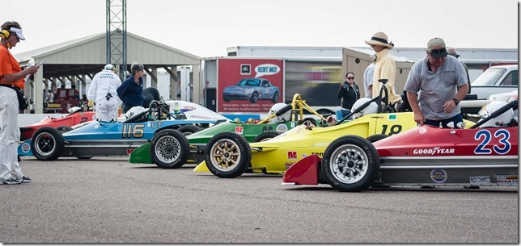

2015 Club Ford Grid photo by Andy Melvin

# Letters to the Editors

It is hard to read and hard to print. I could not read some of articles because of it. when try to print, some articles were chopped off. 

Chris Frank

*(Editor’s response: Sorry to hear about those problems. Please bear with us, as Redline experiments with different font styles to make the words clearer. Ed has also added a PDF button at the top of the viewing page that makes the issue easier to print. Please bear with us, and let Redline know if this makes future issues easier to read.)*

I was completely blown away at the evolution of Redline. From a creative content and literary standpoint this is an outstanding leap forward by a few individuals who have worked quietly in the background to SHOW US ALL THEIR LOVE for the Club.

I have been involved in creating national advertising content for more than twenty years. The content and layout these guys have adopted makes our club, Colorado Region, as good as any club out there. This attracts eyeballs and positively builds our brand. A stronger brand means more active members. If you build it…. they will in fact come.

I just cannot say enough how thankful I am to be tangentially associated with these guys. Thank you for such a fine effort and for what you’ve done to demonstrably move our Club forward.

You guys are pretty sneaky just shooting this fine new publication into our mailbox. I can only imagine the feeling of accomplishment you had when you hit ‘send’. It was well-founded.

Bob Melvin

*(Editor’s response: Thanks for the kudos, Bob. Redline is all about trying to keep racing alive in our neck of the woods. As we strive to continually improve our content, quality and coverage, Redline hopes to do just that.)*

[](http://www.go4itservices.com/)

[](http://www.rockymtnautosports.com/)[](http://www.homes4racers.com/)

# 2016 SCCA Runoffs Qualification Criteria

U.S. Majors Tour Path Divisional Path

Participate in a MINIMUM of 3 separate Majors weekends AND 3 individual race finishes (must be in the same class but can be from any conference)

Participate in a MINIMUM of

4 Runoffs Qualifier event

weekends in a single Division (must be in the same class)

Plus any of the And

following:

≤ 20 Class Participants

Finish in the Top 10 of your

Class Conference point standings

>20 Class Participants

Finish in the Top 50% of your Class Conference point standings

Finish in the top 3 in Class in your Division points standings.

SM/SRF/SRF3 – Finish in the top 5

For CN/GL/NE – (2016 Only) Top 50% of the Division point standing, if space permits in the class

**OR**

Finish in Top 50% of your class in the Nationwide point standings

**OR**

Achieve a point total in your class in the Nationwide point standings ≥ 2015 point target\*

|  |  |  |  |
| --- | --- | --- | --- |
| Nationwide Point Target | | | |
| AS – 77 pts | FE – 87 pts | GT3 – 88 pts | SRF3 – 55 pts |
| B‐Spec – 102 pts | FF – 64 pts | GTL – 42 pts | [../Ad%20Images/3rauto_even.png](mailto:info@3rauto.com)STL – 32 pts |
| EP – 50 pts | FM – 79 pts | HP – 60 pts | STU – 50 pts |
| F500 – 92 pts | FP – 58 pts | P1 – 64 pts | T1 – 46 pts |
| FA – 63 pts | FV – 65 pts | P2 – 50 pts | T2 – 101 pts |
| FB – 79 pts | GT1 – 51 pts | SM – 19 pts | T3 – 85 pts |
| FC – 60 pts | GT2 – 48 pts | SRF – 28 pts | T4 – 95 pts |

# 2016 Rocky Mountain Division Schedule

by Redline

Mark your calendars and get those cars ready! Start early if you want to qualify for the Mid-Ohio Runoffs or win a Rocky Mountain Division Championship in 2016.

|  |  |  |
| --- | --- | --- |
| Date | Event | Track |
| Mar 19-20 | Crash & Burn School | North Washington FD |
| Feb 27-28 | Mid-States Majors | NOLA Motorsports Park |
| Apr 09-10 | Mid States Majors | Hallett Motor Racing Circuit |
| Apr 30-01 | Mid States Majors | MotorSports Ranch-Houston |
| Apr 30-01 | Quad Regional – CTT/PDX | High Plains Raceway |
| May 11 | Track Night in America | High Plains Raceway |
| May 28-29 | Mid States Majors – Dbl Regional CTT/PDX | Pueblo Motorsports Park |
| Jun 15 | Track Night in America | High Plains Raceway |
| Jul 02-03 | Mid States Majors – Dbl Regional CTT/PDX | High Plains Raceway |
| Jul 20 | Track Night in America | High Plains Raceway |
| Jul 23-24 | Quad Regional – CTT/PDX | Pueblo Motorsports Park |
| Aug 10 | Track Night in America | High Plains Raceway |
| Aug 20-21 | Quad Regional – CTT/PDX | High Plains Raceway |
| Sep 19-25 | SCCA Runoffs | Mid-Ohio SportsCar Course |
| \*Oct 15-16 | Quad Regional – CTT/PDX | Pikes Peak Intl Raceway |

\* - Tentative

Important Note: We need lots of workers and participants to make this a successful season. Drivers, if you are not competing, please consider helping with corner staffing. We will need people to assist with the Track Night in America (TNiA) events too. If you work a TNiA event for a minimum of two hours would get at least one 20-minute on-track session.

# 2016 Tech Stations in RMDiv

# 2016 RMDiv Rules

**ROCKY MOUNTAIN DIVISION SCCA DIVISIONAL CHAMPIONSHIP SERIES- 2016 RULES & REGULATIONS**

**1 DEFINITION**

1.1 Championship Series- This series shall be known as the Rocky Mountain Divisional Championship Series, also referred to as the RMDIV Series and shall determine annually the champion Rocky Mountain Division race drivers in SCCA race competition classes as listed in GCR 9.1, and additionally shall provide competition for any other classes, as defined in the Supplementary Regulations.

1.2 Term of the Series- The series shall begin with the first race after the Runoffs and shall end three weeks before the subsequent Runoffs.

**Drivers must participate in a minimum of at least two Divisional events and must finish at least eight (8) races in the same class to be eligible for the championship.**

**2 ELIGIBILITY**

2.1 Membership and License requirements- Members of the SCCA who hold a Novice Permit or Full Competition License are eligible to enter the series.

2.2 Registration for the Series- All SCCA members who finished at least one RMDIV event shall be automatically entered into the Divisional Championship Series.

**3 RACES**

3.1 Designation - All regularly sanctioned Rocky Mountain Division races providing competition for all classes as specified in section 1 of these regulations will be defined as RMDIV Championship races, unless the organizing region specifically excludes its event from the series. In such cases, that region has the obligation to include a notice of exclusion in its Supplemental Regulations, and to notify the Rocky Mountain Division Scheduling Administrator and the series pointskeeper.

3.2 Race Length- Series races shall be scheduled for at least 15 minutes duration, or at least 25 miles in length.

3.3 Interrupted Races- If a race is terminated before the overall leader has run half the scheduled distance and not restarted or rescheduled, half (1/2) points will be awarded.

3.4 Entry forms for each Rocky Mountain Division regional race entry form shall bear the notice, either on the entry blank or in the supplemental regulations, that the race is an event of the Rocky Mountain Division Championship Series.

**4 SERIES SCORING**

4.1 Points - Majors points awarded to those competing in the SCCA Majors Championship series are not affected by the RMDIV Championship. RMDIV Championship Points will be awarded per the following for all events including Majors events. 1st - 12 points 2nd - 9 points 3rd – 7 points 4th – 6 points 5th – 5 points 6th – 4 points 7th – 3 points 8th – 2 points 9th – 1 point Qualifying and/or other preliminary races may be awarded points as specified in the supplemental regulations.

4.2 Runoffs Qualification- Drivers in Runoffs eligible classes may be invited to the Runoffs, if they are in the top three (top five for SM and SRF) in points. Drivers may be required to upgrade their competition license before their entry is accepted.

4.3 Minimum Number of Events - Drivers must participate in a minimum of at least two Divisional events and must finish at least eight (8) races in the same class to be eligible for the championship**.**

4.4 Maximum Number of Events- A driver's accumulation of points from the best ten (10) finishes. Points will be awarded for one out of Division race. Date and location to be announced.

4.5 Drivers who earn an invitation to the Runoffs through the Majors Championship shallnot take up one of the 3 or 5 allotted invitations available through the Divisional Championship. This provision is intended to maximize the number of competitors that can qualify for the Runoffs.

**5. POINTSKEEPER**

5.1 Appointment - The series pointskeeper shall be appointed by the Rocky Mountain Executive Steward each year.

5.2 Championship Records- The pointskeeper will record all series event results and will periodically report to the Executive Steward the points earned by all drivers in all classes.

5.3 Points Publishing- The pointskeeper will prepare a compilation of points beginning after the second event and will update the points standings after every subsequent event. These will be posted at Hospitality at all Divisional events. Copies will be available to all entrants. A final standing, indicating trophies to be awarded will be distributed to RMDIV region webmasters as soon as possible after the last event of the year.

**6 AWARDS**

6.1 Trophies Championship Awards - Trophies will be awarded based on the number of series drivers in each class using the numbers standard of GCR 3.8.2.

6.2 Champions- Class champions will be those drivers having the highest series scores in each class and have met the participation requirements of section 4.3.

6.3 Ties for Awards- If a tie exists, the award will go to the driver who: 1) scores the most victories among series entrants; 2) scores the most second-place finishes among series entrants; 3) scores the most third-place finishes among series entrants, as needed; including any first, second, and third place finishes beyond the drivers’ best 10 finishes. If the scores are still tied, all entrants with that score will be considered tied for that position and trophies will be awarded to each tied entrant.

6.4 Driver of the Year- One driver shall be designated as the Rocky Mountain Division Driver of the Year, and will be awarded a special plaque to be presented at the Rocky Mountain Division Convention. The award winner will be chosen by a committee led by the division pointskeeper, and composed of the Division Administrator of Flagging and Communications and one driver from each run group.

**7 GENERAL**

7.1 Rules- In all series events, procedures not specifically addressed in these regulations shall be per the current GCR and the published Supplemental Regulations for the event.

7.2 RMDIV Series Not Restrictive- The series described is not restrictive of any of the activities and procedures of any SCCA region, and is for the purpose of

supplementing the established SCCA programs, as well as strengthening Rocky Mountain Division racing for all competitors.

7.3 Rule Changes- Changes and/or addendums to the Rocky Mountain Division Regional Championship rules must be approved by the Regional Executive (or their assigned representative) from every region holding a road racing event in Rocky Mountain Division during the current season.

# [../../tomahawkp1_1000.jpeg](http://www.tomahawkp1.com/)

# The Good Old Days

by Bob Wilson

(Editor’s note: This month the late Bob Wilson takes us on a journey back to the early 60’s and a peek into his introduction to working corners. As always, Redline Magazine appreciates his estate allowing us to reprint his articles.)

The first two segments of my story established that we were becoming entwined into the SCCA’s amateur racing scene. Well, of course it was amateur because that’s what the SCCA did in those days. There was no pro racing tolerated by the club and I’ll have more on that subject later. Since I was beginning to consider myself more and more of a sporty car type, I went completely over the edge and about December of 1961 I bought a 1958 MGA Roadster. Now, for beginners, you’ve got to be wired to buy a British roadster in the middle of the winter. To the MG’s credit, it usually started pretty well and the heater performed about as well as two lit matches! I’d like to say I spent many hours analyzing which car of this type to go for, but actually, I bought it because it was bright red and I loved the way it looked. Ila looked on all this askance and assumed that I had reached total senility at the ripe old age of 31, but after she had driven the MG a few times, it suddenly graduated from Bob’s toy to Ila’s sportscar.

Driving the roadster around was a terrific hoot and we were always cheered by the attention it got. Right here we will expound upon the phenomenon of those times known as the WAVE. Now if you drove an MG, Triumph, Healey or Alfa and if you saw another, you gave a knowing wave. But you had to be aware of the pecking order, because if you met a Jaguar or Mercedes, you waited for some signal (usually a raised finger) from this higher order of person before you could wave to him. The one holdout to all this camaraderie was the Porsche driver. We always figured this species was the snootiest of the snooty, but in later times it has been learned that since most of the Porsches were coupes, they were embarrassed that their tops wouldn’t go down. I look forward to the outcry from the Porsche freaks.

**… but after she had driven the MG a few times, it suddenly graduated from Bob’s toy to Ila’s sportscar.**

[](http://www.rockymtnautosports.com/) But I digress. Let’s get back to the days when we started working race groups. Sometime in the early spring, I was invited to a pre-race meeting in Boulder at someone’s house--the names escape me at this time—when the guy conducting the meeting made a plea for workers. Since Bob Riley was about to move away from Denver, I thought this might be a good thing to do, so I volunteered to work corners. Amazing how easy it was, but little did I know what was to follow would not be nearly as easy! Well, Ila and I signed up for the first event that year. The Flag Chief was a nice guy named George Clymer. He gave us a quick session on flags and what they mean. Now in Colorado the term flags actually meant paddles. Each was made out of thin Masonite cut to the appropriate shape and size and painted for the intended signal. This was attached to a heavy wooden handle and weighed anywhere from three pounds to 300, depending on how long you held them overhead and how hard the wind was blowing. These paddles stayed in use until the early 70’s when we got rid of them and had *real flags* made. I’m sure the current F&C workers have no idea what a favor we did for them. Besides being heavy and awkward, the simple transport of them was a major problem. I’d like to say we built a huge bonfire of them and danced madly around it, but I really don’t know what happened to them at all. The first race we worked was a regional race at Continental Divide Raceway (CDR) and I don’t remember the dates, but the weather gods were not pleased with us. Naturally, we drove down in the MG to show we were true sportscar types. Communication in those days was handled by CB radios owned by the track. Now, those were the old type jobs and your car battery had to provide the power to keep them running. The officials warned us to keep running our engines often to keep from running down the batteries. The MG of course didn’t care for this type of operation, but we managed on that score. We were assigned to turn #2, a fast downhill lefthander that saw very little action that day. We were located on the inside of that turn (driver’s left) and stood right near the edge of the turn. During that day it started out nice, but the weather deteriorated. First it rained, then hailed, then snowed, then rained some more. I remember being amazed that these strange helmeted people and their racecars just kept coming by, no matter what the weather threw at them! Later, after being soaked and frozen for countless hours, I was ready to start shooting those guys just so I could get warm and dry. Ila, of course, stayed mostly in the car and kept her battery charged and yelled out messages to me, the flagger.

**… I’d like to say we built a huge bonfire of them and danced madly around it, but I really don’t know what happened to them at all.**

[](http://www.homes4racers.com/) One thing I remember from that first day as a comer worker. It seems that when the moisture began falling, in its many forms, I put out the yellow and red slick flag and kept it out for lap after lap. Finally the Chief Steward called Ila and ordered the flag be taken down. I was aghast since the course was still slick, but control said all the racers had seen the flag, so it should be taken down. I guess my idea was if these guys were dumb enough to stay out in the rain and snow, they wouldn’t be smart enough to know when the track was slick- not an altogether unreasonable assumption yet today. That incident has stuck with me all these years, and in later years I’m sure I’ve been more understanding of the feelings of rookie workers and drivers. Ila and I didn’t work all the Colorado Region races that year, but we did go and spectate quite a lot since a friend had given me a season pass to CDR for the balance of the year. I don’t remember too much about the other club races at CDR, although I think we did work more events than that first weekend.  
 Two notable exceptions were the first airport race at Alliance, Nebraska, and the first ever professional road race in the country. With this ploy, I hope to whet your appetite for next month’s segment of the Good Old Days.

# [../Ad%20Images/go4it.jpg](http://www.go4itservices.com/)Spec Boxter CRE

By Keith Hall

**An Invitation to all PCA Club Racing participants in the SPEC BOXSTER (SPB) class**

You are invited to join the Colorado Region SCCA in our new SPB Class for our 2016 regional race season.

Because of the large number of really enthusiastic PCA Club Racing SPB racers in the Rocky Mountain Region we have formed a brand new SCCA SPB class just for you! Well - OK, it is for everyone, but what we actually have done, *and this is really cool,* is that we have imported the PCA Club Racing SPB rules--word for word--just for the SPB class.

That means if your Spec Boxster is 2016 PCA CR legal it can race with Colorado Region SCCA without modification. That goes for the driver too. Show up, present your PCA log book and your competition license and race. Additionally, we will have PCA race officials on hand to help make certain that your SPB is PCA legal and to make certain that the races are run just like a PCA Club Race.

The point of all this is that you can use these RMDiv SCCA races to prepare for the big PCA race in September. You don't have to tow for two days to get some serious racing in anymore. When the big dogs from Texas show up at HPR in September, you will be ready.

**The SPB Class will be available for your personal use on these three dates in 2016:**

**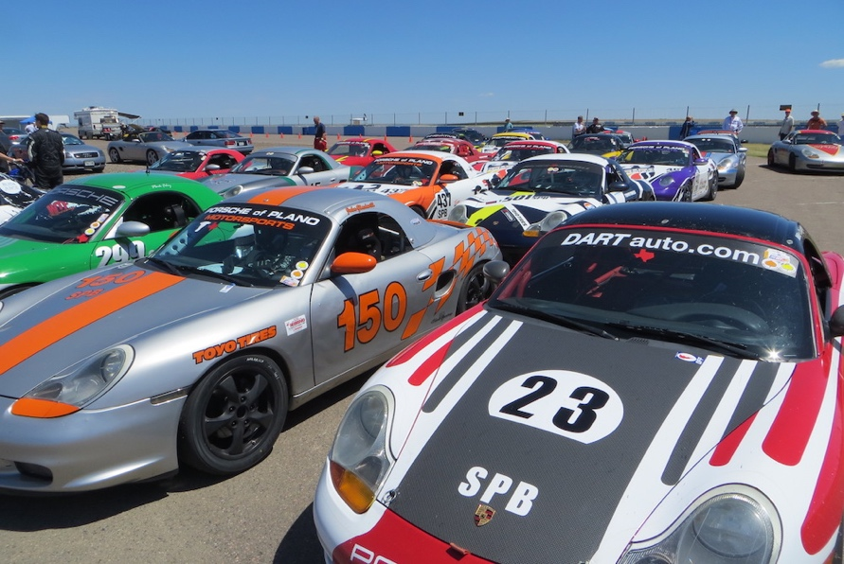**

**April 30-31 at HPR**

**July 23-24 at PMP**

**Aug 20-21 at HPR**

# Fast Lap for NOLA Motorsports Park

# Quad Regionals – A New Driver’s Four-Leaf Clover

By RowOne

[](http://www.homes4racers.com/)

Last year was my first year racing with SCCA and it was definitely filled with many memorable moments – both the ups and downs. This is the very essence of racing. Fulfilling the requirements for a full competition license, I found the Quad Regional format, which is unique to Colorado Region SCCA, to be incredibly conducive for me as a driver starting out in the world of Club Racing:

1. I am sharing driving duties in a racecar with Ed Shuler. This racing format guarantees us 2 races each day of the weekend.
2. The format presents twice as many shots at finishing shorter races that will count towards a full competition license. This was especially helpful when unexpected racecar woes came into the picture. Ed and I completed all the races we started, in no small part due to diligent car preparation.
3. There were twice as many opportunities to go through the preparations for a race (suiting up, getting in the car, pit and grid, pace lap, race start, race finish, impound, and work between sessions). It became less overwhelming rather quickly.
4. With the absence of a practice session, the emphasis was on the qualifying session to learn the track and this challenged me to make the best of each lap. Subtracting warm up, cool off and laps avoiding spinning cars I had on average 3 laps to put a quick lap time on the board. This is similar to the top professional open wheel race series in the United States and made me feel like one of those drivers going through this qualifying format. I enjoyed this challenge.
5. We used the time between all these races to improve the car and our driving techniques by sharing feedback and comparing notes.
6. With approximately 8 laps per race, I found I could really push the car hard with less concern of a non-finish.
7. The length of the on track sessions are nearly identical to the sessions I did in my racing schools and made me feel quickly at home with SCCA.

I am about to complete the paperwork to obtain my full competition license, but will still be racing in these Quad Regionals this year with Ed as we continue to improve ourselves and the #8 Mysterian. We will be officiating the Majors as usual, both being nationally-licensed flagging and communications marshals. I cannot wait to get back to the track to see how the car will perform with all the improvements we are making over this winter.

Thank you, Colorado Region SCCA for Quad Regionals – this format has really helped our development as racers in a safe and positive environment.

# The Quest

by Ed Shuler

[](mailto:eshuler@mac.com?subject=Become%20part%20of%20the%20RMSidewinders)ARE YOU MAKING PROGRESS?

*“The lesson here is simply that courting approval, even that of peers, puts a dangerous amount of power in the hands of the audience. Worse yet, the audience is seldom in a position to grant (or withhold) approval on the one issue that really counts—namely, whether or not you’re making progress in your work. They’re in a good position to comment on how they’re moved (or challenged or entertained) by the finished product, but have little knowledge or interest in your process. Audience comes later. The only pure communication is between you and your work.”*

~ **David Bayles** and **Ted Orland** from ***Art & Fear***

The winter projects continue, but damn it’s cold in that garage!

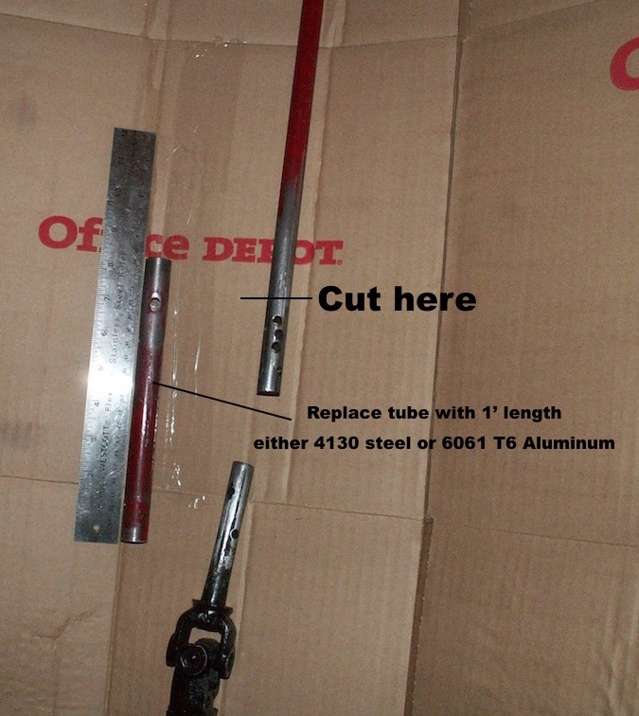The front end is back on the car. A new steering shaft connection tube has been installed. The steering wheel alignment has not been perfect since the car was purchased. And, rather than point the steering wheel straight and adjust the steering connecting rods to make the car go straight, I pointed the car straight and tried to adjust the steering wheel by drilling new holes in the connecting shaft. I ended up with a swiss cheese steering shaft (saving weight)! The new connecting shaft is in the car and ready to be pinned to the VW steering box and steering wheel. I’ll get as close as possible and make adjustments the correct way this time.

There was some play in the chassis bearings of the rear suspension. I am convinced this is the cause of the *Mysterian Shakes* (described in the January issue). Almost all the bolts in the rear suspension had a short grip length. Once the new bolts arrived from Pegasus Racing and the rear suspension was reassembled, the play was eliminated. I can’t wait to get the car back to the track to see if this has eliminated the problem.

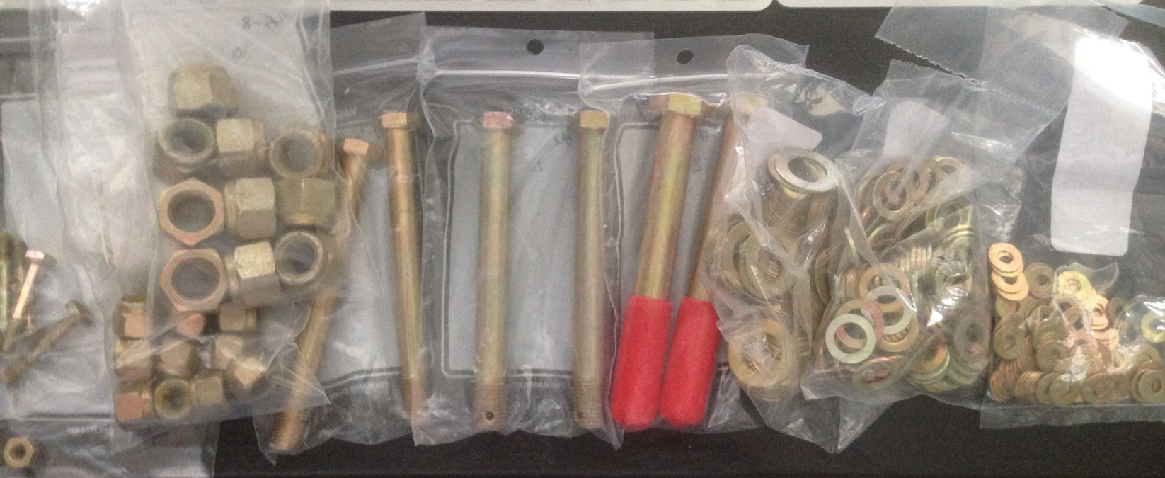

Bolts to eliminate the Mysterian shakes.

The rear drums were turned and are ready to be reinstalled. Uh-oh.. it looks like one of the shoes bound up in the hydraulic cylinder causing uneven shoe wear and failure. Looks like we need some new rear shoes!

**[](http://www.homes4racers.com/)**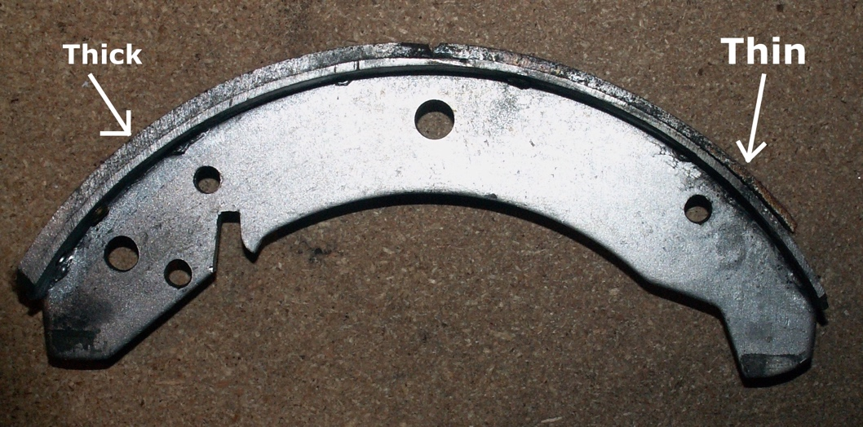The work continues… We still have to decide if we are going to rebuild the engine this winter. In the meantime does anybody have a garage heater I can borrow?

Photos - Ed Shuler

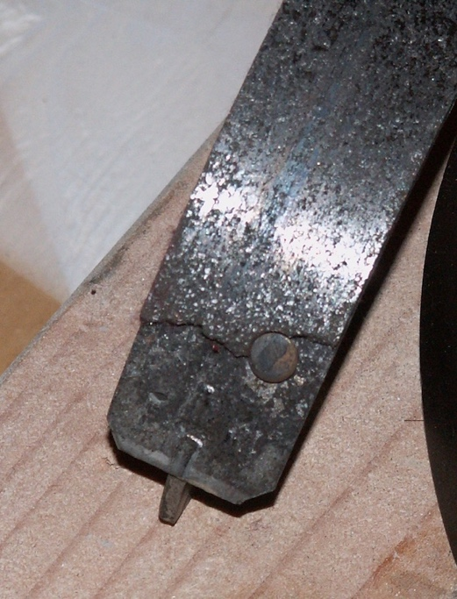

****

# SnakeBytes

By RMSidewinder

**Rolex 24 Hours of Daytona**

As winter arrives in earnest along the front range, and football season winds down, thoughts naturally turn to warmer days and sports car racing. The 24 Hours of Daytona will begin in a few weeks and there is an excitement in the air that I haven’t felt in a long time. The new Ford GT will be competing. The **Fords** will be wearing car numbers 66 & 67 and will be running out of the Ganassi stable. The Ford GT will have an international driver lineup, but it will be great to see Ford back on the grid in a serious way.

Are any Sidewinders going down to work the race?

**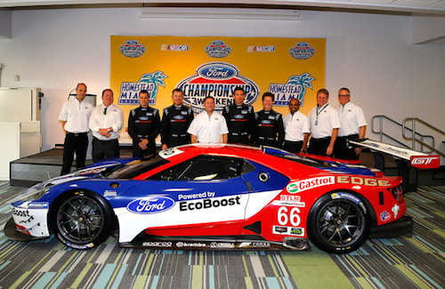2016 C&B**

Mark your calendars, the **2016 Crash & Burn School** is scheduled for March 19 & 20th at the North Washington Fire dept. building (add address). Look for detailed information as we get closer to the date. Do you get the RMSidewinder email blast? If not send a note to [eshuler@mac.com](mailto:eshuler@mac.com) and I will add you to the blast list.

The first, best chance to work a pro race in 2016 will be the **World Challenge** Race at **Circuit of the America’s** March 3rd through the 6th, anyone interested in making the trip? Drop Ed Shuler a line, maybe we can share the ride/expenses and start 2016 off with a road trip.

Photo - Ford Performance

The **World Racing League** (WRL) will be running a true 24-hour event at High Plains Raceway on Aug 27-28. Look for more details here in the coming months.

# The 2016 Air-Cooled Sprints

By Ed Shuler

The 2015 Air-Cooled Sprints was such a success, the decision has been made to run a year long series in 2016.

Each of the Scheduled Quad Regional weekends will host an Air-Cooled Sprint ‘***Club Racing Experience’*** (CRE) group. The group is open to anyone with a air-cooled VW powered formula car. This includes the 1600cc VW powered regional class for Formula First (FST), the vintage 1385cc VW powered Formula Vee (FV-1385) and the current SCCA Formula Vee class (FV-1200) for 1200cc VW powered cars.

The preliminary Air-Cooled Sprints Schedule:

|  |  |
| --- | --- |
| Date | Track |
| Apr 30- 01 | High Plains Raceway |
| Jun 11-12 | Miller Motorsports Park |
| Jul 23-24 | Pueblo Motorsports Park |
| Aug 20-21 | High Plains Raceway |
| Oct 15-16 | Pikes Peak Intl Raceway |

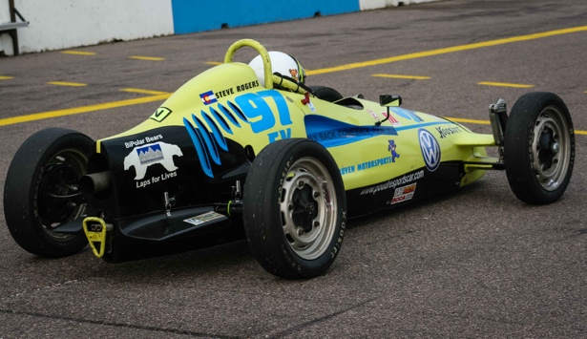

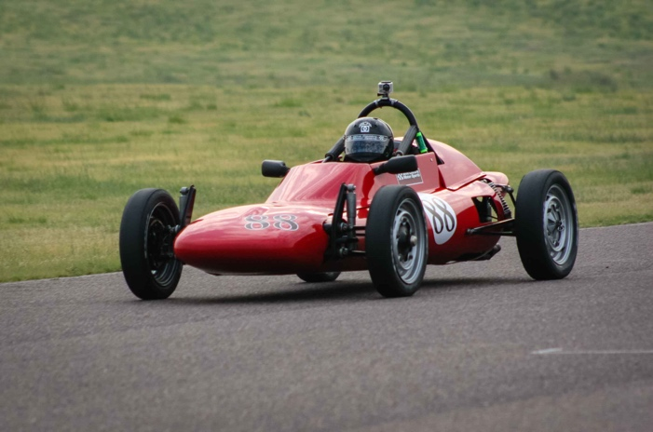

The rules are designed to be inclusive: if you have a VW powered car, a drivers license, and an SCCA membership, (weekend memberships are fine) come and race with us.

There will be prizes, great competition, good friends and fun.

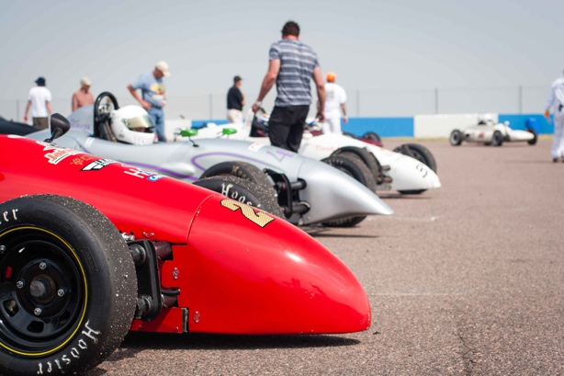*Photos – Courtesy – Andy Melvin.*

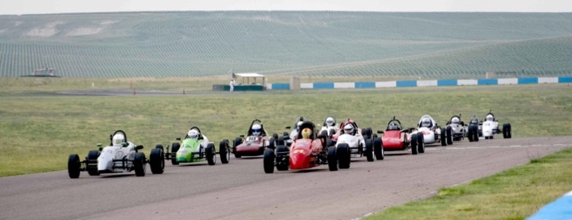

# Tall Tales: Toyota Tundra TRD Pro

by David Muramoto *(photos courtesy of Toyota)*

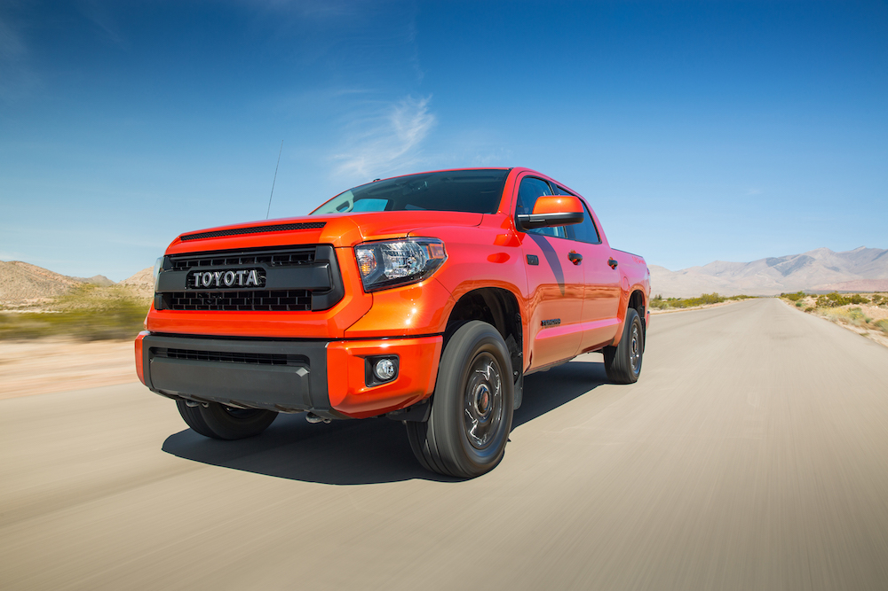In a year when many of us will be using half-ton trucks for work and play, it’s worth knowing what’s available on the market for 2016. The all-new Ford F150 was reviewed last year ([August 2015 Redline](http://www.coloradoscca.org/redline/redline.php?volume=2015&issue=August&page=8)), and is among a new generation of what are still considered light duty trucks. But we all know better: whether it’s hauling heavy loads on the job or simply commuting back-and-forth, a good, dependable truck is essential for a myriad of tasks- most of which are NOT lightweight! One of them might be whether it can safely tow a racecar to HPR, Pueblo or any other race venue in or out of state. This brings us to Toyota’s Tundra TRD Pro- a vehicle that can make many of us feel vertically-challenged.With special remote reservoir Bilstein shocks, 2” lifted suspension and black alloy wheels, this is one tall truck! Designed to be used as an off-road runner and capable of crossing a variety of surfaces, steep hills or dips. As such, running boards or nerf bars to step into this double cab pickup would only get in the way, but anybody under 5’10” will have to reach way up once you open the door. Then you can grab onto a handle or steering wheel, and hoist yourself into a very comfortable seat.

Once inside, this Tundra features a cabin that is both rugged and industrial looking, with a dash of luxury sprinkled in. The black cloth seats have red inserts and piping with ‘TRD Pro’ stitched in (in case you forgot what you were driving) and there is a center console with a gearshift lever for a sporty image. The instrument panel features large silver knobs for the HVAC system, analog gauges and a large 7.0” color display in the middle. I found all the controls pretty much intuitive, with no big surprises for anything from changing radio stations to using the on-the-fly 4WD switch. Toyota has done a nice job in creating a truck interior that will appeal and serve a wide variety of customers. Of course, there’s Bluetooth, USB ports, nav traffic and a host of entertainment options available. Like most trucks, this one still uses a key, but has a key FOB with wireless remote starts ($500 option), for those particularly cold days. On one of those days, I enjoyed testing the navigation system by entering a destination cross-town and driving a route contrary to what the system wanted me to take. Can you say “recalculating”? It’s interesting to see whether the nav system keeps up, but I have to say, this system not only figured out what alternate route I was taking, it added some backdoor directions that even surprised me! Handling such a tall truck took just a moment to adjust to, with a ride that handled bumps and potholes easily.

**This brings us to Toyota’s Tundra TRD Pro - a vehicle that can make many of us feel vertically-challenged.**

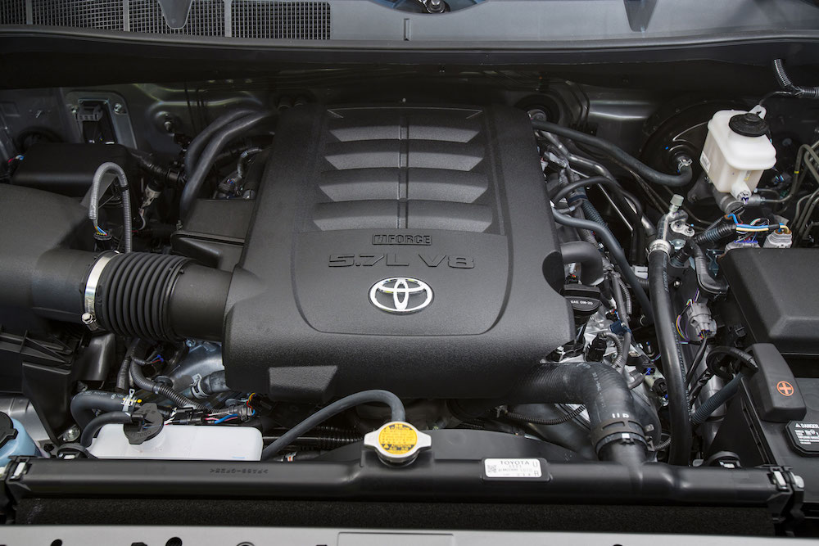 Fire up the 5.7-liter I-Force V8, and hear the nice rumble from the dual exhaust, stainless steel TRD muffler. It reminds you of the 381 HP/401 lb-ft TQ under your right foot that is ready to roll when you are! Before the days of traction/stability control (TCS), that kind of power might have been difficult to put down, especially during the wintery days just before Christmas when this test drive was conducted. But with TCS engaged, and with a 4.38 rear end and limited slip, there was no need to even engage 4WD. This truck runs on regular unleaded (13 city/17 highway/15 combined), with a 26.4 gallon tank to hold all that $1.93/gallon fuel (the ’16 models will come with 36 gallon tanks). I wanted to see how this Tundra would perform with my 24’ enclosed race trailer hitched to the stout receiver, and was surprised by how level it remained with almost 9K pound load on a weight-distributing hitch. Toyota also adds both engine and tranny coolers to the TRD package and features a tow mode switch to keep the six-speed tranny in lower gears for longer periods for maximum towing efficiency. The Tundra easily pulled my trailer around the snow covered streets of a quiet neighborhood and I’m confident it would do the job on highways as well. Unfortunately, the 2015 Tundra TRD Pro I tested doesn’t come equipped with an integrated brake controller (2016 models will) and I was unwilling to take my fully loaded trailer out onto heavily traveled roads without one. Braking remained adequate, but with the Tundra already weighing 5,470#, there was some ABS pulsing over snow packed roads without trailer brakes to share the load. One feature worth noting: integrated into the left side of the rear bumper was a black, oval shaped electrical/brake hookup. Lift the cover on the left side and you have a standard 2” round, seven pin connector, while on the right side (also covered) is a smaller four-pin connector used by many smaller, open utility trailers.

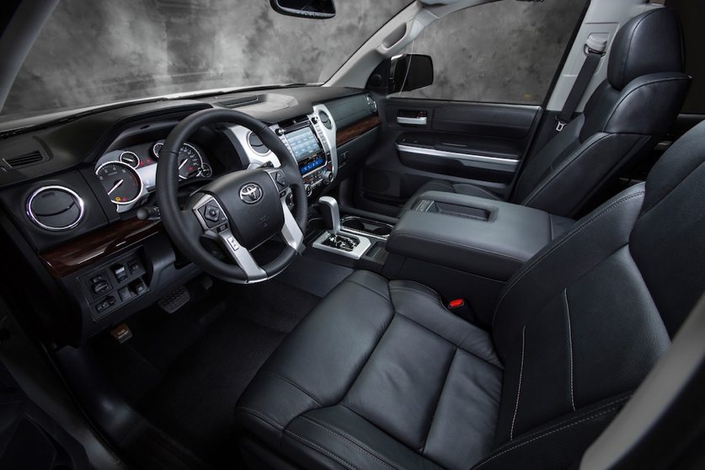 List price for this Tundra TRD Pro was $43,658, which (believe it or not) is within the current price range for half-ton trucks. But I found the $1,100 delivery, handling and processing fee a bit steep for simply transporting a truck from Toyota’s plant in San Antonio to Colorado. You can bet THAT would come up during any negotiating session for a vehicle like this. And in a day and age when $40 large is considered the *middle* point for a nice half-ton truck, buyers might find an advantage in knowing what is available and where the Tundra fits into the market. Since this Tundra was first introduced as a 2014 model, the Big Three have all refreshed their light duty truck lineups and rival Nissan has a new turbo diesel powered half-ton Titan coming to market in 2016. So don’t sweat it- your local Toyota dealer might be more than a little interested in giving you a great deal to get another V8 Tundra out the door and into your driveway.

[](http://www.rockymtnautosports.com/)

# Classifieds

**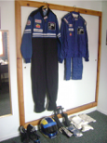**

**Driver Gear for Sale**

The following is for sale:

• 2 driver suits , blue, one full suit and one two piece will fit a driver from 175 to 225 lbs.

• 1 newly painted Bell helmet, size “large”

• 1 Hans device

• 1 pr shoes , black size 9 1/2

• 2 pr socks, one new

• 2 pr gloves, one new

• 1 Nomex set, short sleeve shirt and shorts

• 1 set arm restraints

I’m asking $1000.00 for the complete set, will discuss pricing.

Inquiries can be made to Richard Fischer at 406-842-5026 or MTlogger@outlook.com

**2003 Z4 built and prepped by Bimmerhaus.**

Car built by Bimmerhaus. Car is prepped and ready to race, nothing is needed. Car holds the SSB track record at HPR. Refreshed engine with 25k miles.

Suspension components are all new.

Added in 2014 was a custom LSD by Performance Gearing.

11 wheels and 4 rain tires (mounted on new wheels).

Price includes spares but does not include RaceKeep and Aims dash.

Asking $18,500.

Email or call Rick at 303-666-8486 or [mshively3@comcast.net](mailto:mshively3@comcast.net)

**NEW AND USED TIRES**

315/35-17 Kumho 710s and Toyo R888s, Call Michael @ 303-666-4113.

**T3 Mustang – Price Reduced**

Tube frame construction with 1997 Mustang body. Esslinger 2.3 liter, 4 cyl engine, freshly rebuilt. 12 wheels, one set is brand new still in boxes. Borg Warner T5 tranny. New clutch slave installed.

Several thousand dollars in new, high performance upgrade parts waiting to be installed, including high flow intake manifold and new dual Weber hi volume carbs, upgraded exhaust manifold. New brake ducting. New Koni double adjustable gas shocks. 12 sets of springs. 6 sets of new brake pads.

The car currently does not have the body on it, new owner needs to complete the reassembly and installation of upgrade components. Engine and drive train is installed. Been in storage for 5 years.

Asking $6,500.

Bubba, 303-229-5893, or email [bobrocho@gmail.com](mailto:bobrocho@gmail.com)

**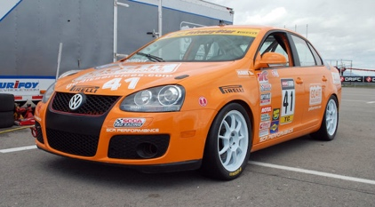2007 VW Jetta GLI**

2007 Volkswagen Jetta GLI- SCCA STU & World Challenge TC- Build from a body in white from VW, seam welded and caged by Built by Bones, and the rest of the car was built by SCR Performance. 2012 and 2013 SCCA RMD STU Champion, multiple lap records. Many spares. $45,000./OBO Call Michael 303-666-4113 see the car on [www.go4itservices.com](http://www.go4itservices.com).

**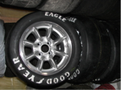Race Tire and Wheel Inventory Sale**

One set of refurbished Panasport Ultralight wheels. 15 X 7.0” with 3.5” backspacing on a 4 X 4.5” bolt pattern. Never run after being checked, magna-fluxed and refinished with fresh silver powder-coat. $600/set These are all used R-compound radial tires that have been properly stored in a climate-controlled basement. All have multiple heat cycles, but would be well suited for practice, testing and lapping days. Year of manufacture listed after description:

Three (3) Goodyear RS - 275/35-18 - (2011) $20 each or $55/all

Two (2) Hoosier R6 - 285/30-18 - (2010) $25 each or $45/pair

One (1) BFGoodrich R1 - 285-30-18 - (2010) $30

Two (2) BFGoodrich R1 - 275-35-18 - (2011) - $30 each or $80/all

Contact David Muramoto: [nissan7gt3@comcast.net](mailto:nissan7gt3@comcast.net)

**Miscellaneous Race equipment**

Black vacuum-formed plastic twin air inlet for bumper or air-box. Measures 15.5 X 9.5”. $30

Two 1/2” plastic socket holders from Craftsman and Pittsburg Mfg. These are designed for deep metric sockets and go from 10-34 mm. $5/each

Contact David Muramoto: [nissan7gt3@comcast.net](mailto:nissan7gt3@comcast.net)

**Formula Ford, FF2000 and Formula Atlantic mechanical and body parts**

Crankshafts, camshafts, front and rear suspension, steering, anti-sway, front and rear uprights, pistons, rods, rocker arm assemblies, intake manifolds, headers, flywheels, clutches, bolt-on and knock-off wheels, noses, side panels, crush boxes, tails and snorkels for Lola, Van Diemen, Swift, etc. A trailer-load of parts, located in north Denver. Buy some or buy all.

Call Ron Kessinger at (303)287-7092.

[](http://www.rockymtnautosports.com/)

**Post Your Stuff**

SCCA member?

Advertise your personal racing stuff here for free.

Ads in by the 20th of each month will be in the same month’s issue.

Contact: [mailto:redline@coloradoscca.org?subject=Redline Classifieds](mailto:redline@coloradoscca.org?subject=Redline%20Classifieds).

More classifieds are posted by forum users and updated more frequently on the Colorado Region [Forum](http://www.coloradoscca.org/msg/)

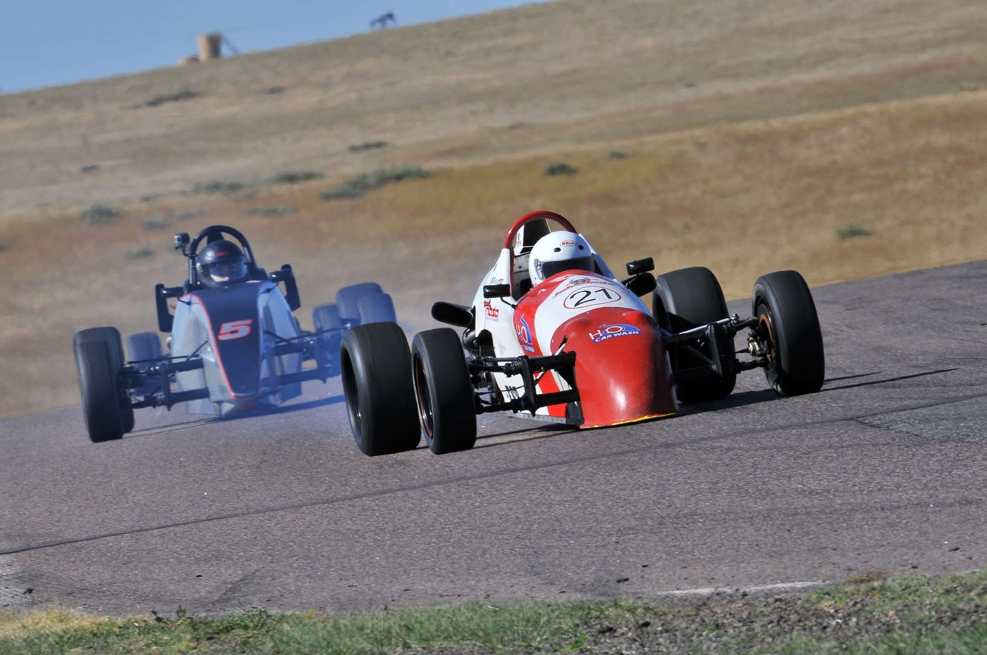 *Formula First racers from the 2015 Air-Cooled Sprints. Photo courtesy Rupert Barrington*



# Advertiser Index

Please support these loyal Redline advertisers

**Go4It Racing Services**: 303-666-4113 [Go4It Racing Schools](http://www.go4itservices.com/)

**The McColl Team**: 303-940-9128 [www.homes4racers.com](http://www.homesforracers.com/)

**3R Racing Services**: 303.781.0774 [shop.3rauto.com](http://shop.3rauto.com/)

**Rocky Mountain Autosports**: 970-282-3446 [Rocky Mountain Autosports](http://www.rockymtnautosports.com/)

REV UP YOUR SALES

**COLORADOSCCA.ORG** is the official website of Colorado Region SCCA (Sports Car Club of America). Advertising on the site presents an excellent and affordable opportunity for Denver metro businesses to attract customers from the local racing community. The SCCA has the largest amateur racing presence in the state and draws drivers, crew and spectators to the website and newsletter. The club recently won a national award for it‘s accelerated membership growth, and that growth is expected to continue now that High Plains Raceway has opened it‘s doors just east of Denver.

Redline is the official newsletter of the Colorado Region SCCA , published online monthly January-November. In January 2009 Redline was adapted to a web-based format. In just a few short months readership has increased dramatically and currently accounts for about 25% of the club‘s (non message board) web traffic.

READERSHIP

• 15,000 page views each month; 25% are regular readers of Redline

• Ads are displayed at random on each page, so readers may see every ad on the most popular pages.

• The average reader spends about one full minute reading each page.

• The website and Redline magazine reader base is a targeted car and racing enthusiast audience, based primarily in Colorado.

• Several times each month, the entire local SCCA membership (2,000+) receives reminder emails about events, website postings and a Redline publication notice.

# In your Mirrors

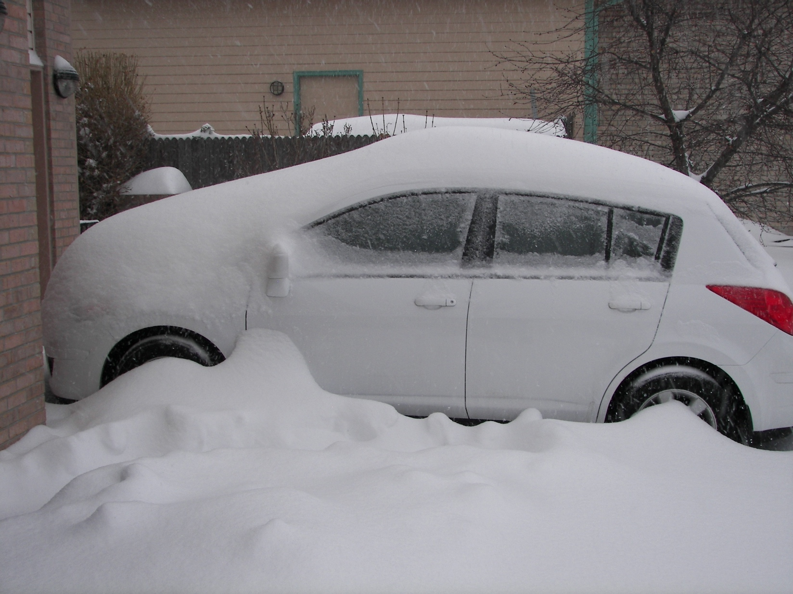

**Advanced automotive aero designs are continually undergoing high-altitude testing in Colorado... Photo by David Muramoto**



Imagine your full backcover ad here.

Contact [redline@coloradoscca.org](mailto:redline@coloradoscca.org)

for more info.